Traffic-EV Forecasting Pipeline

Preprocessing schema

The preprocessing system begins by loading the traffic and electric vehicle (EV) data from CSV files. The first step is to perform temporal alignment (Temporal Alignment A), where data is filtered and synchronized to ensure consistency across time intervals. Next, the EV data is resampled to align perfectly with the traffic data (temporal alignment B).
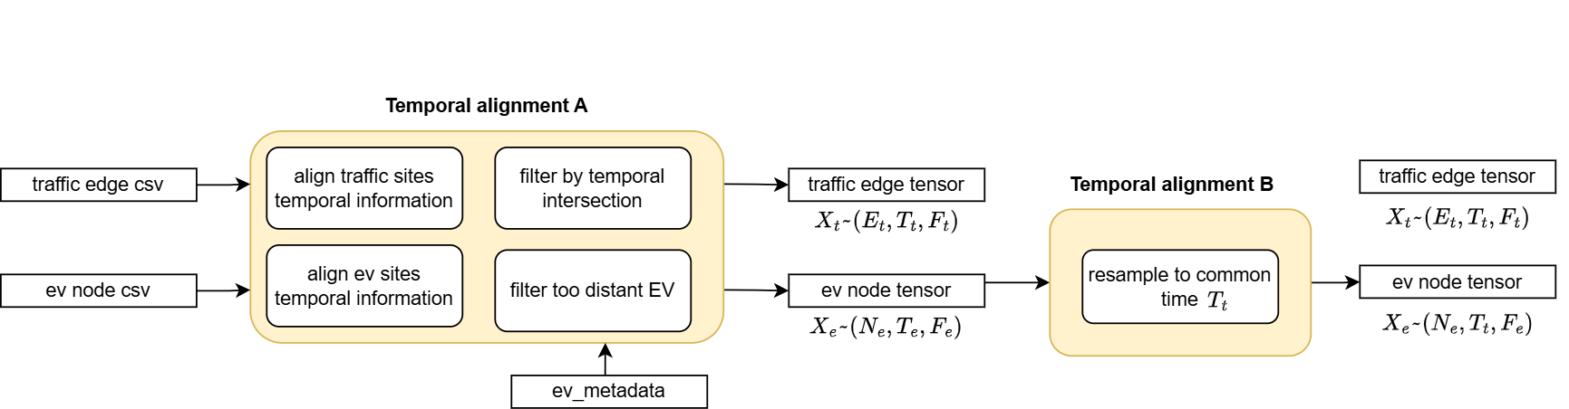
Following this, the graph representing the traffic network is created, including both true and fake connections. The fake connections are introduced to maintain connectivity within the network (Spatial Setup). The traffic data is then projected onto the traffic nodes, and the EV values are assigned to the nearest traffic nodes. Finally, these elements are concatenated to form the final temporal tensor, which includes an adjacency matrix to represent the network structure. This preprocessing pipeline ensures that the data is properly prepared for further analysis and modeling.

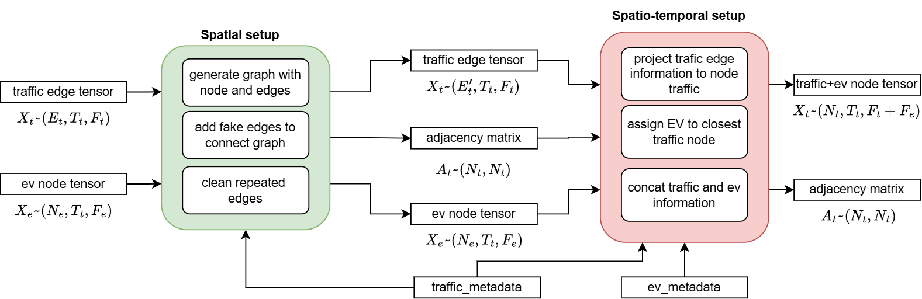

Data preprocessing Chicago
csv files columns
_TRAFFIC_DATA_COLUMNS = ['speed', 'length', 'time']
_TRAFFIC_METADATA_COLUMNS = ['id', 'street', 'length', 'start_latitude', 'start_longitude', 'end_latitude', 'end_longitude', 'max_speed']
_EV_DATA_COLUMNS = ["location_id", "timestamp", "Available", "Total", "Offline"]
_EV_METADATA_COLUMNS = ["LocID", "LocName", "Latitude", "Longitude"]

- check_traffic_ev_time(): Traffic and EV data are not aligned. Neither traffic and EV files itself. So we get start and final time of recording data for both traffic and EV data because we need synchronized data. Then, we define the intersection of those values and we filter both traffic and EV temporal data outside these range (start_time-end_time)
- Dataset starting time: 2025-07-10 03:35:52
- Dataset end time: 2025-09-01 20:50:00
- load_traffic_data(): Loading temporal traffic data from each .csv file. Data is loaded by rows and not strictly temporal alignment since timestamps are not precise. Check duplicate timestamp. Get mean traffic resolution. Filter temporal data by start and end time and, once determined the file with the minimum number of rows, select those rows for all files (since all files have not the precise number of rows). Generate timestamp tensor . Generate temporal traffic tensor with dimension (N,T_t, M), with N number of sites , T_t temporal timesteps e M features (in the chicago dataset are ["speed", "lenght])
- load_ev_data(): Loading EV temporal data from eac .csv file. EV sites are filtered by distance from minimum and maximum latitude and longitude of traffic sites.
# Predefined coordinate limits on traffic sites
self.min_lat, self.max_lat = 41.5, 42.1
self.min_long, self.max_long = -87.9, -87.4

# Cut off too distant EV sites
ev_metadata = pd.read_csv(self.params.ev_metadata_file)
mask = (
ev_metadata['Latitude'].between(self.min_lat, self.max_lat) &
ev_metadata['Longitude'].between(self.min_long, self.max_long)
)
excluded_vals = (ev_metadata.loc[~mask, col]).tolist()

Get EV temporal data mean resolution. Then same procedure as traffic data to collect information. Final tensor has dimension (N,T_e,M) with N number of sites (which in the chicago dataset case are vertices), T_e temporal timesteps e M features (in the chicago dataset are ["Available"])
- resample_to_common_time(): Once aligned traffic and EV data on same temporal span, since they have different resolutions (similar but different)
- Dataset traffic mean resolution: 10.022341966666662
- Dataset ev mean resolution: 5.025388397083335
In detail, EV temporal data is resampled on the traffic temporal slots, since these the data associated is more variable and has elevated granularity. Now, the final length of timesteps is T, which is equal to T_t. The final EV temporal tensor is so modified.
- get_edges_traffic(): Now we have to build the graph having traffic sites as nodes (in newyork dataset we take the start and finish coordinate of the lines as nodes) and road as edges. We load traffic metadata (location_summary.csv):
id,street,length,start_latitude,start_longitude,end_latitude,end_longitude,max_speed
1132,Cicero,1.01,41.8367473974,-87.7439318058,41.8221415535,-87.7437722696,30
1133,Cicero,1.00,41.8512451897,-87.7444337191,41.8367473974,-87.7439318058,20
1134,Cicero,1.02,41.8659627382,-87.7449852043,41.8512451897,-87.7444337191,20
1151,Harlem,1.01,41.8796992839,-87.8045488066,41.8942683013,-87.8051007941,25
1152,Harlem,1.01,41.8942683013,-87.8051007941,41.9088560337,-87.8055536529,25
which contains edge/road-level information. We use this information to get:
- edges : DataFrame with columns [id, src, tgt, distance, src_id, tgt_id]
- nodes : DataFrame with columns [node_id, lat, lon]
Here we convert a dataset of geographic segments into a graph structure. It creates edges from start and end coordinates, assigns each unique geographic point a numeric node ID (merging nearby points within a given distance threshold), and outputs two DataFrames: one for edges (with source/target node IDs) and one for unique nodes (with their coordinates). We normalize direction of arcs. We delete duplicate arcs and update data. Finally, we add fake edges in order to create a connected graph and allow the flow of information during message passing phase of the Graph Neural Network. We keep trace of fake edges in ordr to update temporal traffic tensor with zeros data. Edges are treated in the model learning phase as undirected to allow the flow of information in both directions.
- assign_ev_node_to_traffic_node():
  - We project EV node features into traffic nodes for aggregating information by mapping each EV node to the closest traffic node. And we assign the sum of the combined temporal ev data to traffic nodes.
  - Assign EV temporal information of traffic nodes on traffic edges. We split EV features
  - Merge traffic and EV temporal information at the edge-level
  - Assign merget traffic-EV temporal information on traffic nodes
  - Finally constructing the complete tensor that will have dimension equal to (N_t,T_t,F_t+F_e) with N_t equal to the number of traffic sites, T_f=T equal to the number of traffic timesteps, F_t number of traffic features and F_e number of EV features
- preprocess_and_assemble_data(): Min-max per channel normalization saving min-max values for reconstruction in inference. I save min-max values per channel so it is possible during inference to reconstruct real values

Data preprocessing Newyork
csv files columns
_TRAFFIC_DATA_COLUMNS = ["speed", "travel_time", "status", "data_as_of", "link_id"]
_TRAFFIC_METADATA_COLUMNS = ["id", "link_points", "points", "distances"]
_EV_DATA_COLUMNS = ["location_id", "timestamp", "Available", "Total", "Offline"]
_EV_METADATA_COLUMNS = ["LocID", "LocName", "Latitude", "Longitude"]

- check_traffic_ev_time(): Traffic and EV data are not aligned. Neither traffic and EV files itself. So we get start and final time of recording data for both traffic and EV data because we need synchronized data. Then, we define the intersection of those values and we filter both traffic and EV temporal data outside these range (start_time-end_time)
- Dataset starting time: 7/17/2025 21:08
- Dataset end time: 9/1/2025 20:58
- load_traffic_data(): Loading temporal traffic data from each .csv file. Data is loaded by rows and not strictly temporal alignment since timestamps are not precise. Check duplicate timestamp. Get mean traffic resolution. Filter temporal data by start and end time and, once determined the file with the minimum number of rows, select those rows for all files (since all files have not the precise number of rows). Generate timestamp tensor . Generate temporal traffic tensor with dimension (N,T_t,M), with N number of sites (which in the chicago dataset case are vertices), T_t temporal timesteps e M features (in the chicago dataset are ["speed", "travel_time])
- load_ev_data(): Loading EV temporal data from eac .csv file. EV sites are filtered by distance from minimum and maximum latitude and longitude of traffic sites.
# Predefined coordinate limits on traffic sites
self.min_lat, self.max_lat = 40.4, 40.95
self.min_long, self.max_long = -74.5, -73.5

# Cut off too distant EV sites
ev_metadata = pd.read_csv(self.params.ev_metadata_file)
mask = (
ev_metadata['Latitude'].between(self.min_lat, self.max_lat) &
ev_metadata['Longitude'].between(self.min_long, self.max_long)
)
excluded_vals = (ev_metadata.loc[~mask, col]).tolist()
Get EV temporal data mean resolution. Then same procedure as traffic data to collect information. Final tensor has dimension (N,T_e,M) with N number of sites (which in the chicago dataset case are vertices), T_e temporal timesteps e M features (["Available"])
- resample_to_common_time(): Once aligned traffic and EV data on same temporal span, since they have different resolutions (similar but different)
Dataset traffic mean resolution: 5,0562
Dataset ev mean resolution: 5,0006
In detail, EV temporal data is resampled on the traffic temporal slots, since these the data associated is more variable and has elevated granularity. Now, the final length of timesteps is T, which is equal to T_t. The final EV temporal tensor is so modified.
- get_edges_traffic(): Now we have to build the graph having traffic sites as nodes (in newyork dataset we take the start and finish coordinate of the lines as nodes) and road as edges. We load traffic metadata (location_summary.csv):
id,street,length,start_latitude,start_longitude,end_latitude,end_longitude,max_speed
1132,Cicero,1.01,41.8367473974,-87.7439318058,41.8221415535,-87.7437722696,30
1133,Cicero,1.00,41.8512451897,-87.7444337191,41.8367473974,-87.7439318058,20
1134,Cicero,1.02,41.8659627382,-87.7449852043,41.8512451897,-87.7444337191,20
1151,Harlem,1.01,41.8796992839,-87.8045488066,41.8942683013,-87.8051007941,25
1152,Harlem,1.01,41.8942683013,-87.8051007941,41.9088560337,-87.8055536529,25
which contains edge/road-level information. We use this information to get:
- edges : DataFrame with columns [id, src, tgt, distance, src_id, tgt_id]
- nodes : DataFrame with columns [node_id, lat, lon]
Here we convert a dataset of geographic segments into a graph structure. It creates edges from start and end coordinates, assigns each unique geographic point a numeric node ID (merging nearby points within a given distance threshold), and outputs two DataFrames: one for edges (with source/target node IDs) and one for unique nodes (with their coordinates). We normalize direction of arcs. We delete duplicate arcs and update data. Finally, we add fake edges in order to create a connected graph and allow the flow of information during message passing phase of the Graph Neural Network. We keep trace of fake edges in ordr to update temporal traffic tensor with zeros data. Edges are treated in the model learning phase as undirected to allow the flow of information in both directions.
- assign_ev_node_to_traffic_node():
We project EV node features into traffic nodes for aggregating information by mapping each EV node to the closest traffic node. And we assign the sum of the combined temporal ev data to traffic nodes.
Assign EV temporal information of traffic nodes on traffic edges. We split EV features
Merge traffic and EV temporal information at the edge-level
Assign merget traffic-EV temporal information on traffic nodes
Finally constructing the complete tensor that will have dimension equal to (N_t,T_t,F_t+F_e) with N_t equal to the number of traffic sites, T_f=T equal to the number of traffic timesteps, F_t number of traffic features and F_e number of EV features
- preprocess_and_assemble_data(): Min-max per channel normalization saving min-max values for reconstruction in inference. I save min-max values per channel so it is possible during inference to reconstruct real values

